# Hevo Data Assessment – End-to-End Data Pipeline (PostgreSQL → Hevo → Snowflake)

This project demonstrates the setup of a complete data pipeline using **PostgreSQL (Neon)**, **Hevo Data**, and **Snowflake**.  
It walks through the creation of tables, data ingestion, transformation, and validation from source to destination.

## Overview

The goal was to:

* Set up a Snowflake trial account and connect it with a Hevo partner account.
* Establish a working PostgreSQL environment.
* Ingest data from CSV files into PostgreSQL.
* Connect PostgreSQL to Hevo as a source.
* Apply transformations using Python in Hevo.
* Load transformed data into Snowflake.
* Validate the final results using SQL queries.

## 🏁 **Step 1: Destination Setup (Snowflake Partner Connect)**

### 1️⃣ **Snowflake Trial Account Creation**

* Created a **Snowflake trial account** using Gmail.
* Logged in as admin

### 2️⃣ **Hevo Partner Account Setup**

* Inside Snowflake, navigated to **Admin → Partner Connect**.
* Selected **Hevo Data** from the list of partners.
* Authorized connection → Hevo workspace auto provisioned.

✅ Hevo connected to Snowflake successfully.

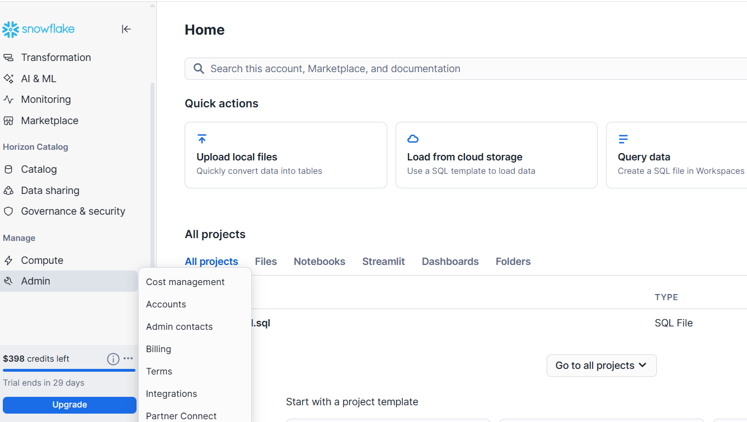

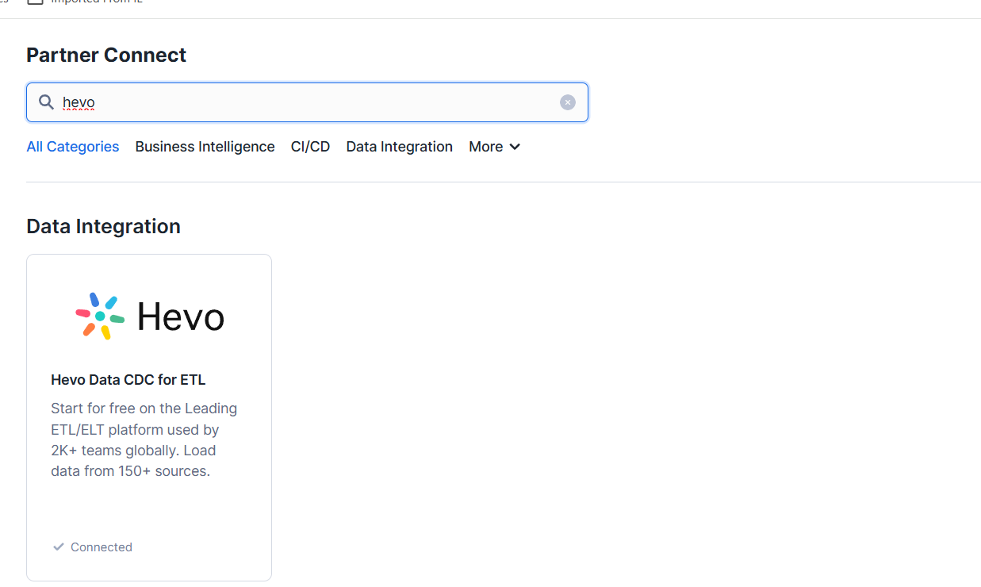

## **Step: Initial Setup Attempt with Docker (and Why It Was Replaced)**

### 1️⃣ **Docker Setup**

* Installed **Docker Desktop** and attempted to create a local PostgreSQL container.
* Verified installation with:
* docker version

✅ The command returned version details successfully.

### 2️⃣ **Issue Encountered**

While trying to launch or connect to the PostgreSQL container, Docker repeatedly threw a **500 API Error**, preventing connection.

### 3️⃣ **Decision**

Since Docker setup was unstable, switched to [**Neon.tech**](https://neon.tech/) — a managed PostgreSQL cloud service with a free tier, GUI, and logical replication support.

## 🧱 **Step 2: PostgreSQL Setup in Neon**

### **Created Neon Account by using URL**

https://console.neon.tech/app/org-mute-band-50763817/projects

* Signed up using Gmail.
* Created a **Neon project and database** named - neondb.
* Default role: neondb_owner. As Attached below

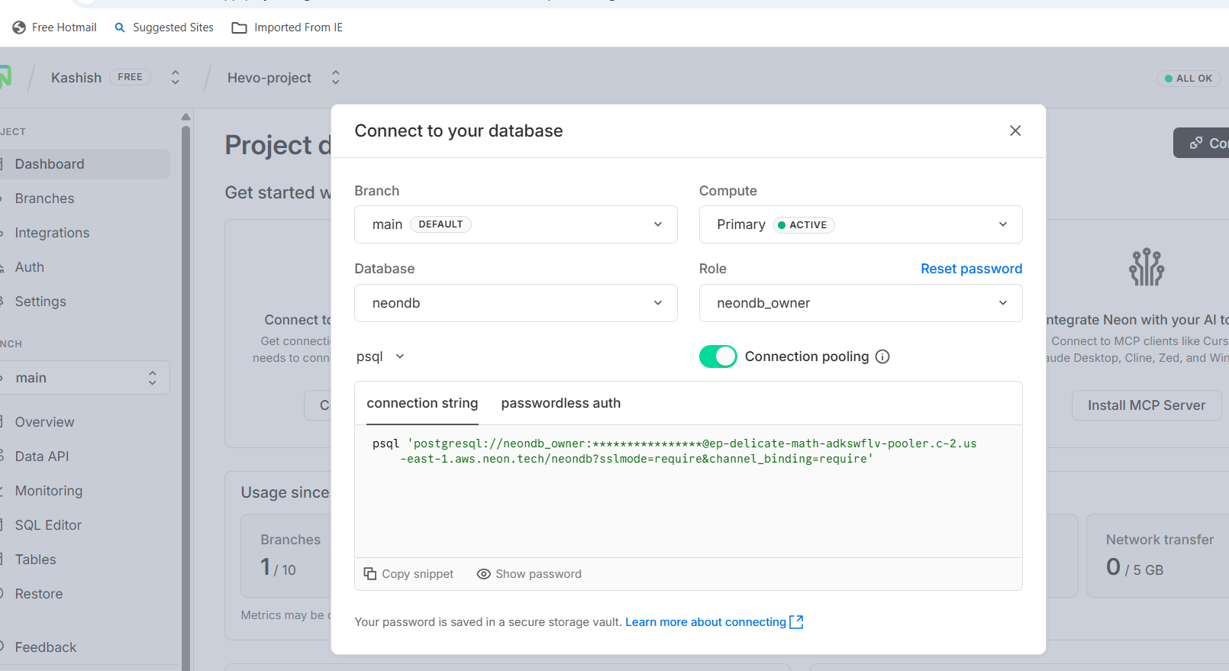

✅ Connection successful.

## **Step 3: Connection via pgAdmin**

Created a new server in pgAdmin named **neondb** with the following credentials:

| **Parameter** | **Value** |
| --- | --- |
| Hostname | ep-delicate-math-adkswflv-pooler.c-2.us-east-1.aws.neon.tech |
| Database | neondb |
| User | neondb_owner |
| Password | ******** |

Connection successful ✅

Note - Where hostname is from Neon connection sting and user too from there  
  
Screenshot attached   
  
How to create new server  
  
  
After server is enter you got below interface you need to put all the details as mentioned above like hostname username password  
  
  
  
  
Once the connection was made I created 3 tables using the create table command under pgadmin sql query and once all 3 tables created

## 🧮 **Step 4: Table Creation and Data Import under PGADMIN**

### **1. Create Tables**

Ran the following SQL under pgAdmin:

CREATE TABLE customers (

id SERIAL PRIMARY KEY,

first_name VARCHAR(50),

last_name VARCHAR(50),

email VARCHAR(100),

address JSON

);

CREATE TABLE orders (

id SERIAL PRIMARY KEY,

customer_id INT,

status VARCHAR(50),

total_amount NUMERIC(10,2)

);

CREATE TABLE feedback (

order_id INT PRIMARY KEY,

rating INT,

comment TEXT

);

### **2. Import CSV Data**

Downloaded the CSV files from the [Hevo Assessment Repository](https://github.com/muskan-kesharwani-hevo/hevo-assessment-csv):  
  
https://github.com/muskan-kesharwani-hevo/hevo-assessment-csv

* customers.csv
* orders.csv
* feedback.csv

Imported them into pgAdmin by right-clicking each table → Import/Export Data.

#### ⚠️ **Issue 1: Invalid JSON Format**

During import of customers.csv, received error:

invalid input syntax for type json

**Root Cause:**  
Values in the address column were not enclosed in double quotes.

**Fix:**  
Changed datatype from JSON → TEXT:

ALTER TABLE customers ALTER COLUMN address TYPE TEXT USING address::TEXT;

Re-imported successfully ✅

#### ⚠️ **Issue 2: Duplicate Key Violation**

While importing feedback.csv, error:  
  
  
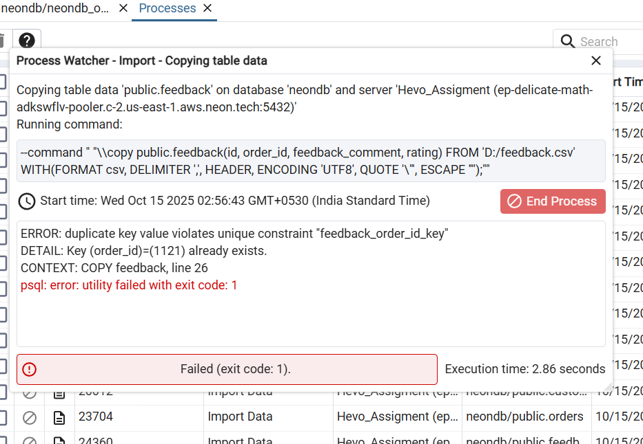

ERROR: duplicate key value violates unique constraint "feedback_order_id_key"

DETAIL: Key (order_id)=(1121) already exists.

**Root Cause:**  
133 duplicate order_id values in the CSV.

**Resolution:**

Used Python (pandas) to remove duplicates and create a cleaned file:

import pandas as pd

df = pd.read_csv('feedback.csv')

df = df.drop_duplicates(subset='order_id', keep='first')

df.to_csv('feedback_clean.csv', index=False)

Re-imported feedback_clean.csv successfully ✅

So, this way I was able to bring all 3 tables with all rows inside it

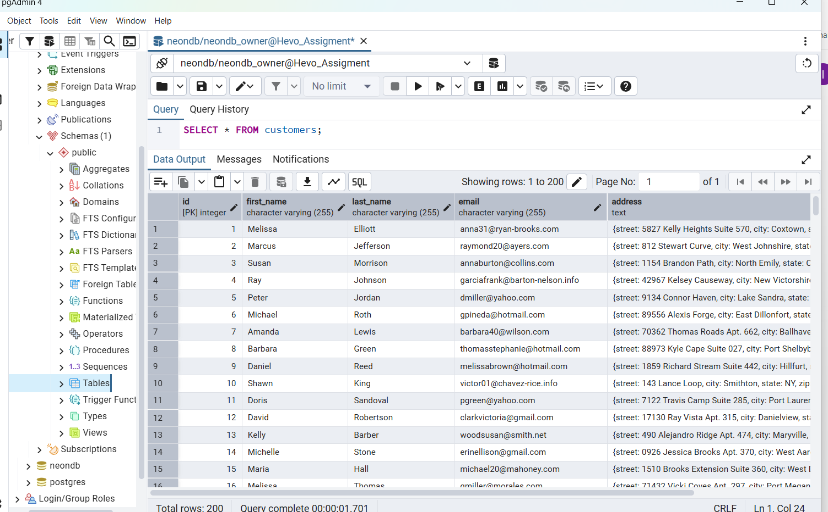

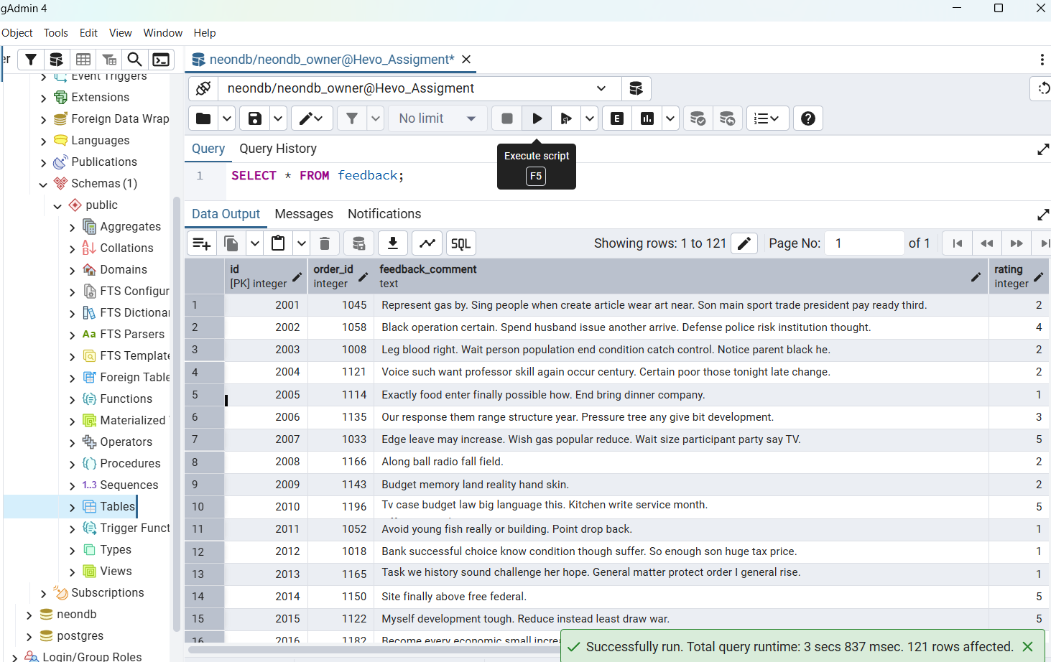

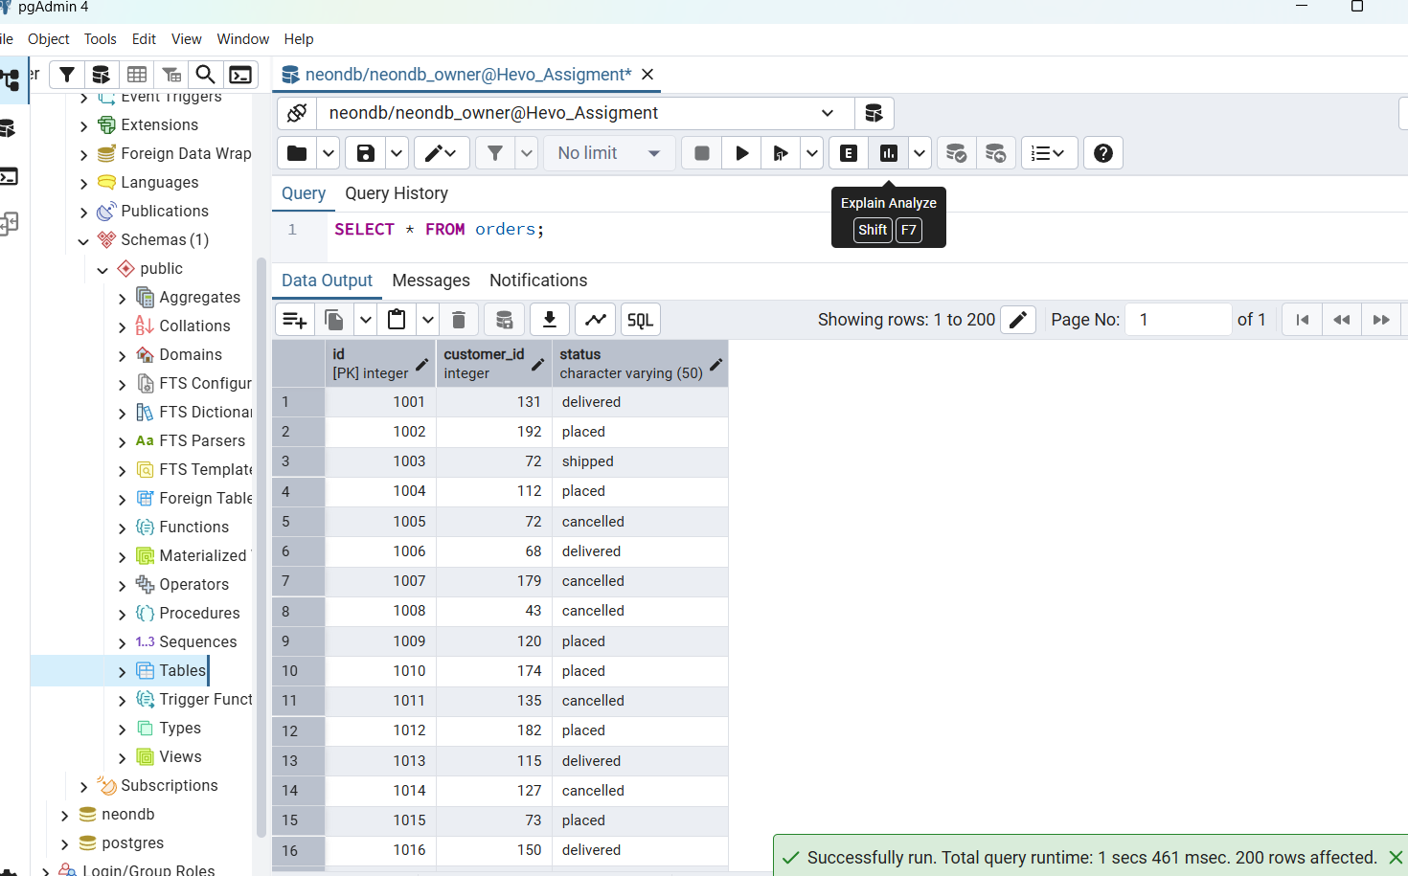

## **Step 5: Connect PostgreSQL to Hevo**

### **1. Created New Hevo Pipeline**

* Source: **PostgreSQL**
* Destination: **Snowflake**

### 2. **PostgreSQL Source Settings** 1. Now I moved to hevo platform side to Configure PostgreSQL Source in Hevo 2. Log in to your Hevo account. 3. Create a new pipeline. Select PostgreSQL as the Source 4. And the Ui seeking some fields like pipeline named database name host 5. I used here the same database host and user and password same as neon side

| **Parameter** | **Value** |
| --- | --- |
| Host | ep-delicate-math-adkswflv-pooler.c-2.us-east-1.aws.neon.tech |
| Database | neondb |
| User | neondb_owner |
| Password | **** |
|  |  |

### Here below we have used the parameter values describes above

### **3. Error Encountered** After entering all the required values and clicked in save and continued

Hevo showed:

Error - Unable to use logical replication. wal_level must be set to 'logical'

### **4. Fix**

* Logged in to **Neon → Settings → Enable Logical Replication**
* Verified using:
* SHOW wal_level;

Output confirmed: logical

Reconnected successfully 🎯  
  
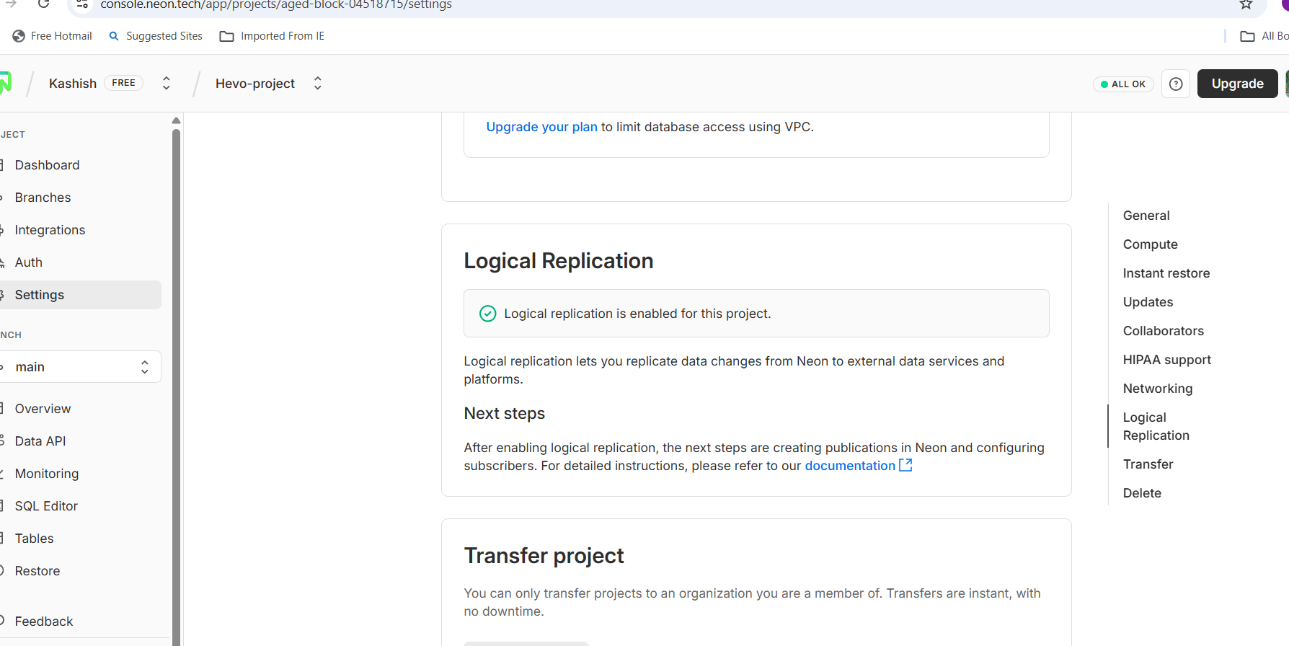  
  
  
Neon side replication enable

Verified if enabled replication

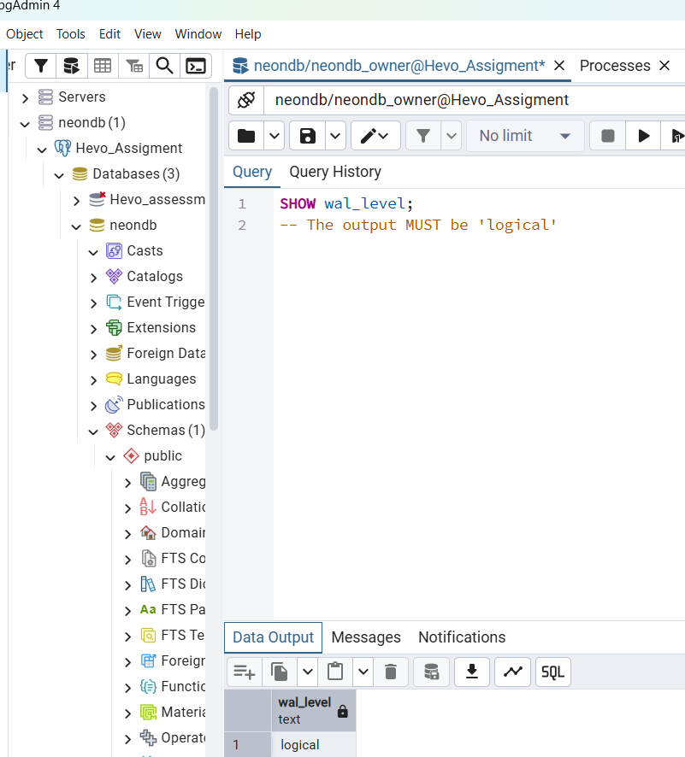

Now go and save and continue and it works it populate you all columns and later last stage ask below info

## 🧭 Step 5: Configure Hevo Pipeline

| **Setting** | **Value** |
| --- | --- |
| Destination Table Prefix | (Blank) |
| Auto Mapping | Enabled |
| Ingestion Schedule | Every 30 minutes |

Once configured, tables from PostgreSQL successfully appeared in Hevo.

## **🧠 Step 6: Data Transformation in Hevo**

Used a **Python transformation script** to enrich and restructure data.

### **🔹 Transformation Goals**

1. Derive username from email in **customers**.
2. Create a new derived table **order_events** based on order status.
3. Pass other tables unchanged.

### **🔹 Transformation Script**

In hevo transform go to transform and create a new transform by below python script

import datetime

def transform(event):

table_name = event.get('__table_name')

if not table_name:

return event, None

# 1️⃣ Add username for customers

if table_name == 'customers':

email = event.get('email')

if email and '@' in email:

event['username'] = email.split('@')[0]

return event, table_name

# 2️⃣ Generate order_events for orders

elif table_name == 'orders':

status_map = {

'delivered': 'order_delivered',

'placed': 'order_placed',

'shipped': 'order_shipped',

'cancelled': 'order_cancelled'

}

status = event.get('status')

output_records = [(event, table_name)]

if status in status_map:

new_event_record = {

'order_id': event.get('id'),

'customer_id': event.get('customer_id'),

'event_type': status_map[status],

'event_timestamp': datetime.datetime.now().isoformat()

}

output_records.append((new_event_record, 'order_events'))

return output_records

# 3️⃣ Pass feedback and other tables

return event, table_name

Transformation deployed successfully ✅  
  
  
  
  
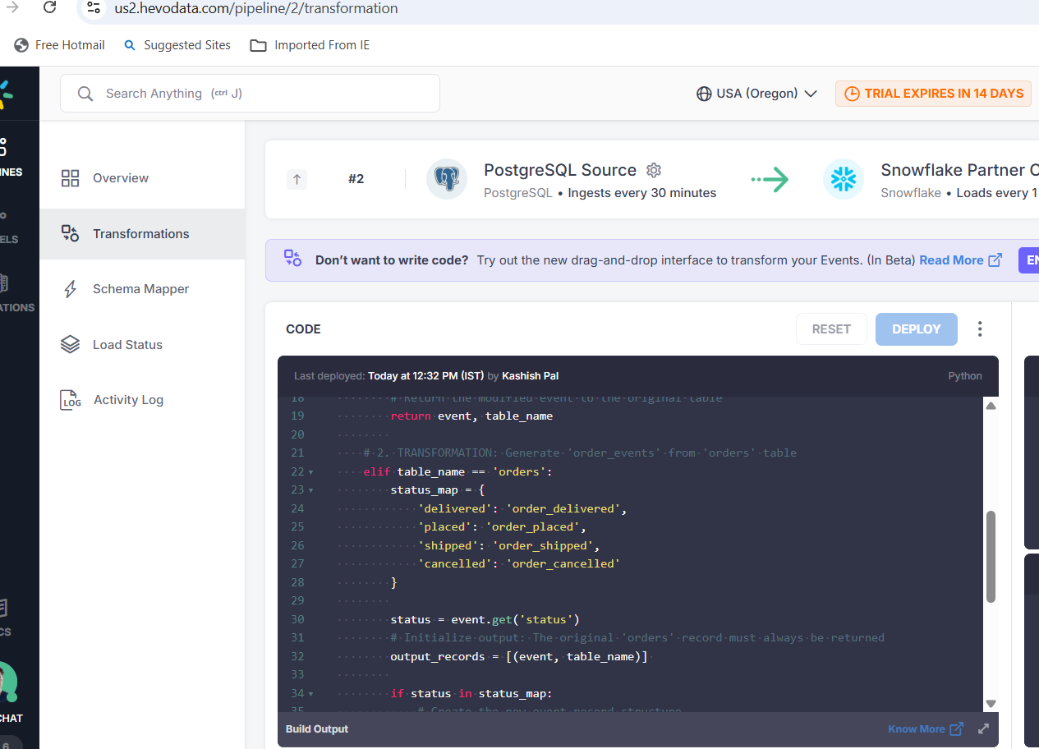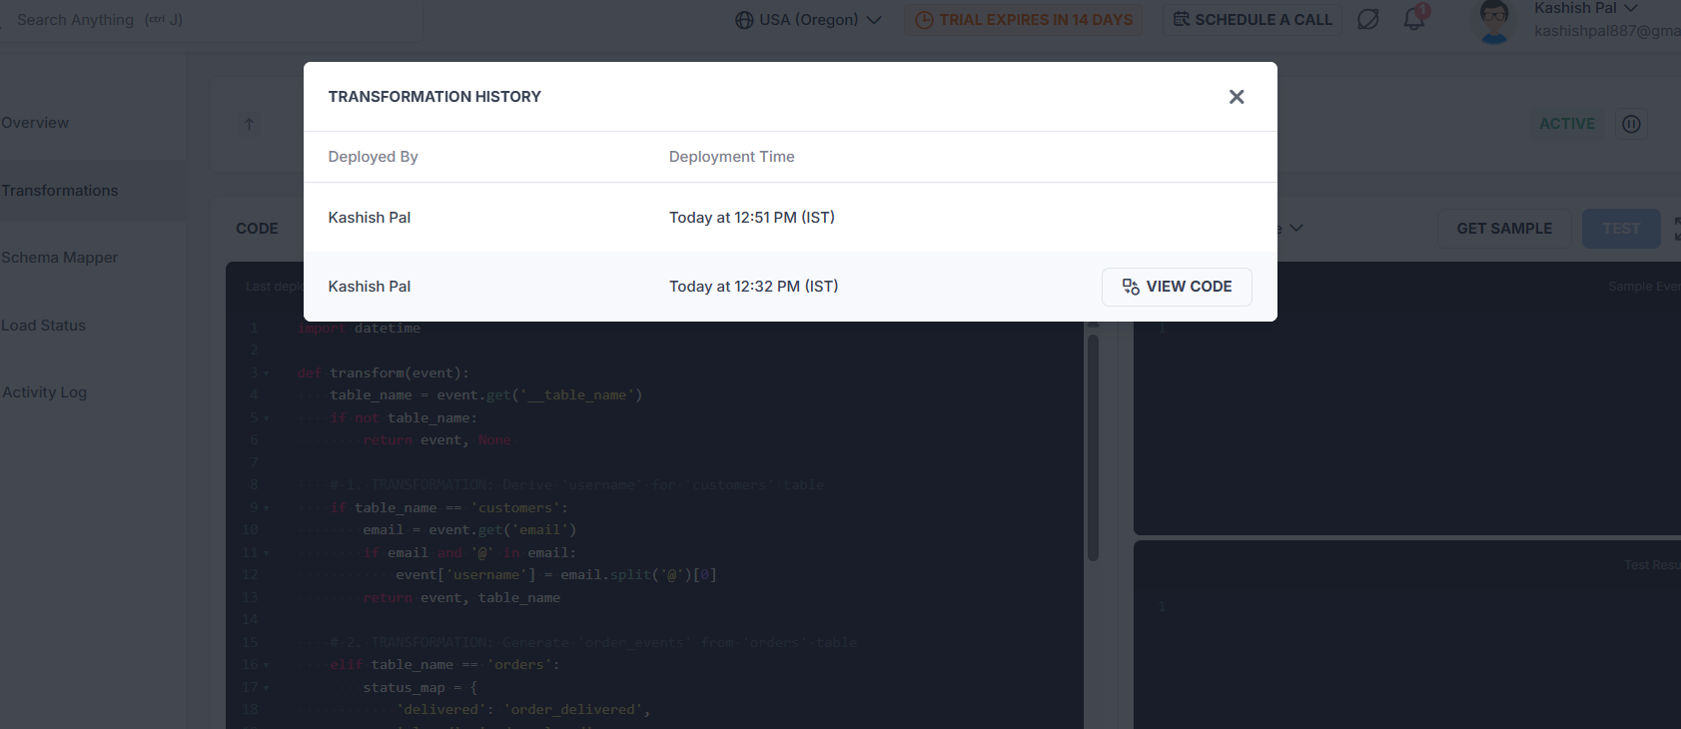

## **❄️ Step 7: Load and Validate in Snowflake**

### **Snowflake Connection**

* Database: PC_HEVODATA_DB
* Schema: PUBLIC

### **SQL Operations**

**Add new column**

ALTER TABLE PC_HEVODATA_DB.PUBLIC.CUSTOMERS

ADD COLUMN USERNAME VARCHAR;

**Populate username**

UPDATE PC_HEVODATA_DB.PUBLIC.CUSTOMERS

SET USERNAME = SPLIT_PART(EMAIL, '@', 1);  
  
  
  
  
  
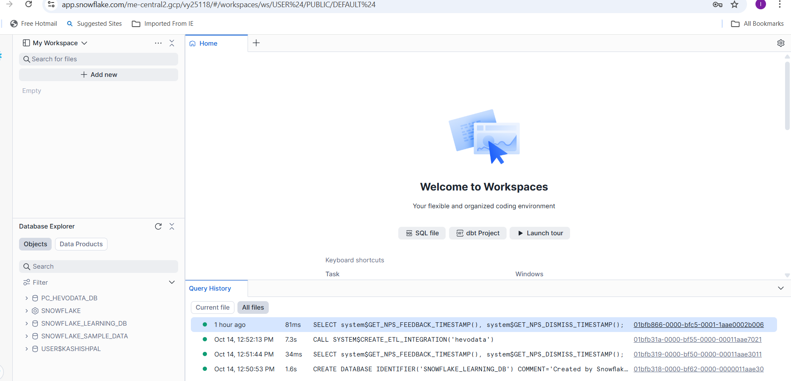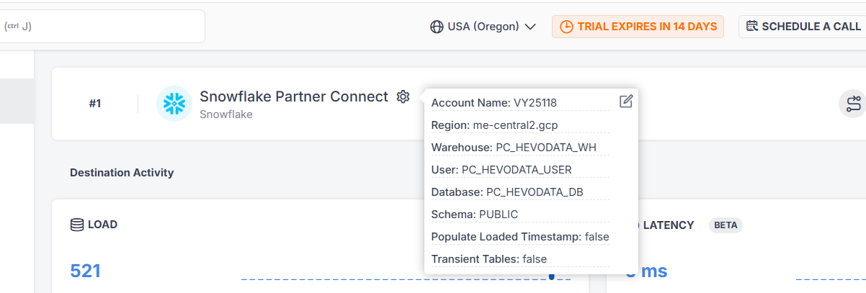

## **🧾 Step 8: Validation Queries**

### **✅ Validation A — Order Events**

SELECT EVENT_TYPE, COUNT(*)

FROM PC_HEVODATA_DB.PUBLIC.ORDER_EVENTS

GROUP BY EVENT_TYPE;

### **✅ Validation B — Username Field**

SELECT EMAIL, USERNAME, FIRST_NAME

FROM PC_HEVODATA_DB.PUBLIC.CUSTOMERS

WHERE USERNAME IS NOT NULL

LIMIT 10;

All validation checks passed successfully 🎉  
  
**Validation A — Order Events**  
  
  
### **Validation B — Username Field**

## **💡 Issue encountered & Design Choices**

| **Category** | **Decision / Assumption** |
| --- | --- |
| **Address Field** | Converted from JSON → TEXT for simplicity |
| **Order Status Type** | Used VARCHAR instead of ENUM for flexibility |
| **Duplicate Handling** | Removed duplicates at source before loading |
| **Transformation Type** | Used Python for precise control |
| **Ingestion Frequency** | 30-minute schedule chosen for steady sync |

## **📁 Repository Structure**

📦 hevo-data-assessment

│

├── README.md

├── sql/

│ ├── create_tables.sql

│ ├── validation_queries.sql

│

├── data/

│ ├── customers.csv

│ ├── orders.csv

│ ├── feedback_clean.csv

│

├── transform/

│ └── transform_script.py

## **🧩 Summary**

✅ Attempted PostgreSQL via Docker (failed due to API 500 error)  
✅ Switched to Neon PostgreSQL (successful)  
✅ Created & populated tables  
✅ Connected Neon PostgreSQL → Hevo with logical replication  
✅ Applied transformations using Python  
✅ Synced data to Snowflake  
✅ Verified successful transformation and data integrity